1. Agenda:
   1. Aggregation and Composition Relationship.
2. Aggregation Relationship: This relationship indicates a relationship b/w a whole and its parts.
3. 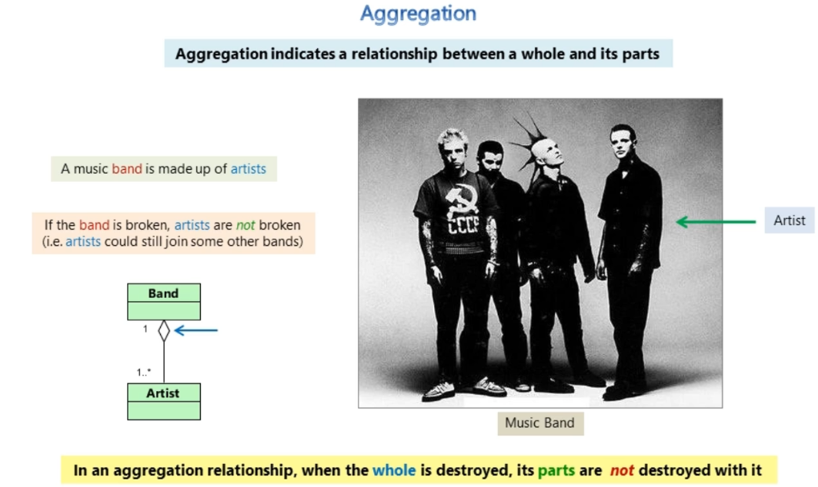
4. Composition Relationship: When whole is destroyed, its parts are also destroyed.
5. 